NEED HELP?
CONTACT US:
www.navigatingreentry.org
info@navigatingreentry.org
443-945-9713
or CHAT

NAVIGATING BARRIERS TO REENTRY
Opening Doors To Success

HOW TO FIND AND EXPUNGE YOUR CRIMINAL RECORDS

1. Go to the Maryland Judiciary Case Search website:
http://casesearch.courts.state.md.us/casesearch//inquiry-index.jsp
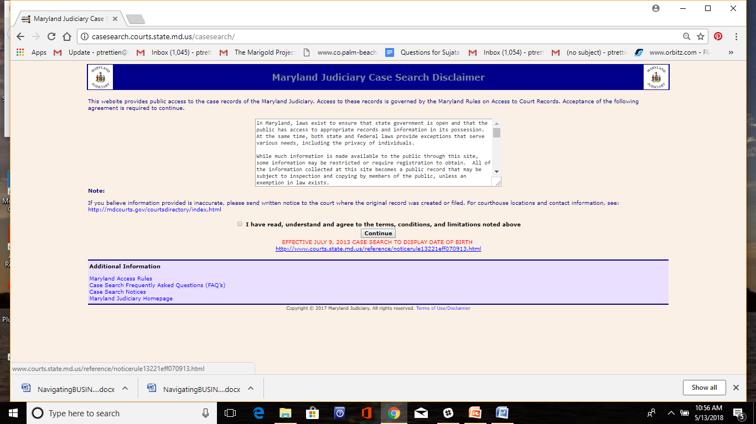

2. Read the Disclaimer box then check
I have read, understand and agree to the terms, conditions, and limitations noted above
3. Click on "Continue" You will be taken to the Case Search Criteria page
The Case Search Criteria Page looks like this:

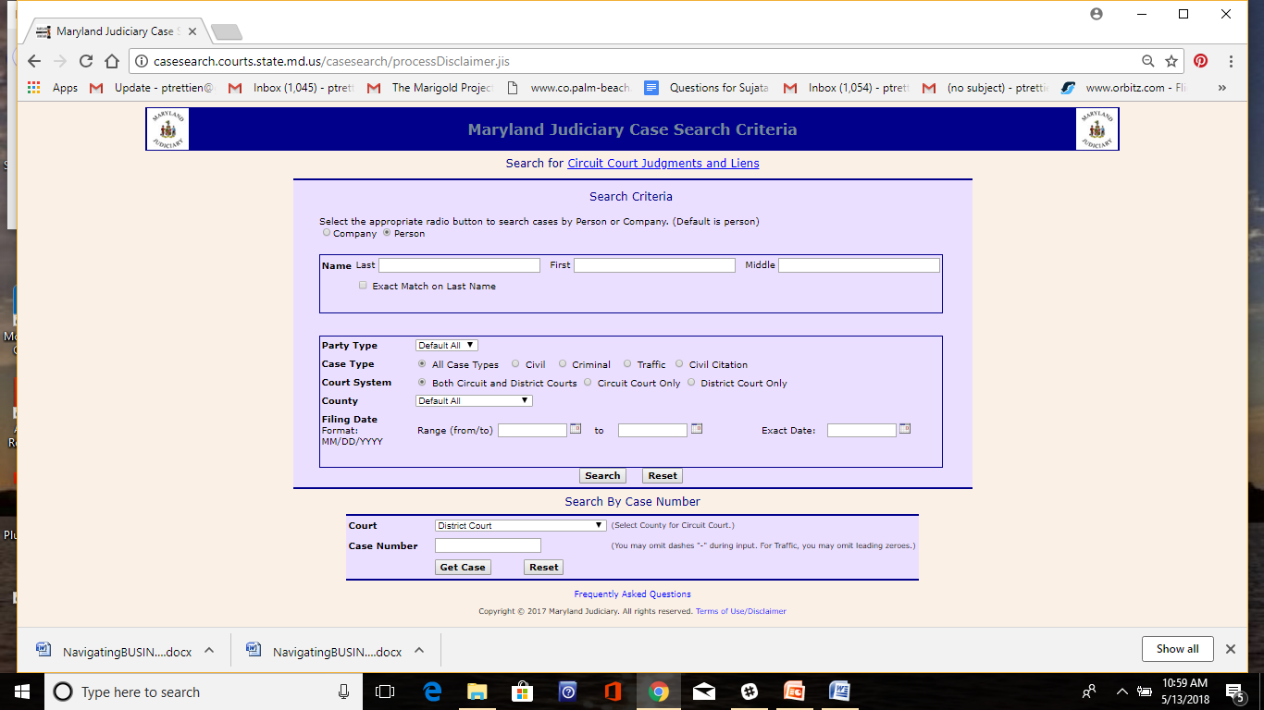

4. Fill in Search Box - Last Name, First Name, Middle Name
5. Case Type - Choose "All Case Types"
6. Court System - Choose "Both Circuit and District"
7. County - Leave the Default - "All"
8. Filing Date - In this field, put in a large range of dates to make sure you capture all your records. For instance: From: "1/1/1990" To: today's date
9. Click on "Search" and you will be taken to the records page

Record Search Page

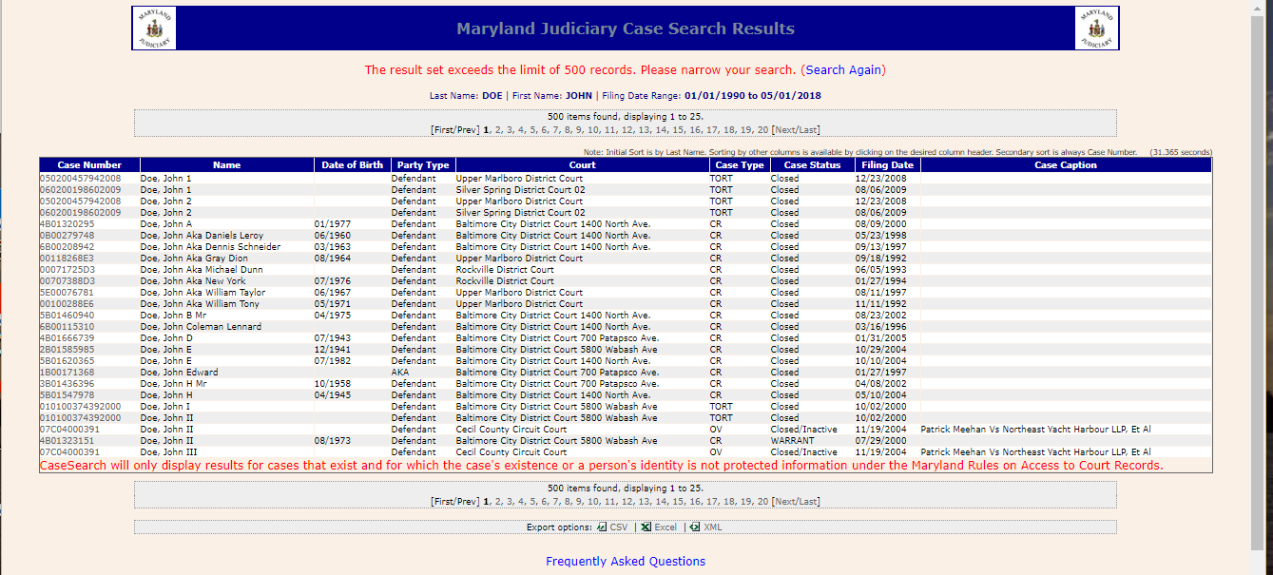
This is the Case Number - you will need this number to file your expungement

10. Find your records. Using date of birth is helpful, also checking for correct address if there are multiple records with the same name.
11. Click on the Case Number once you have located your record
12. The court record will open up. You will only be able to open one court record at a time.
13. Make a copy of each court record so that you can review them for expungement eligibility.
14. If you do not have access to a printer. Write down the Case Number for each of your court records.

e
The Disposition of the case will determine eligibility for expungement
Dispositon of the case - the outcome
Description of charges
Defendant's Plea - This may say Not Guilty - This is not the outcome.
Defendant Identification --make sure this is your record.
This is the Court where the Expungement needs to be filed

WHAT RECORDS CAN EASILY BE EXPUNGED?
- Records with only one charge and
- A Dispositon (outcome of case) of the following
  - Not Guilty
- Nolle Prosequi - the prosecuter decided not to prosecute
- Stet (when a case becomes inactive; applies if no action was taken on your case for more than 3 years)
- Probation Before Judgment - PBJ ( applies if no action was taken on your case for more than 3 years
- Release Without Charge (RWOC)

IF YOU HAVE ELIGIBLE RECORDS - GO TO:

https://www.mdexpungement.com/

